Linear Regression Model on the Iris Dataset
Week 01 : Task 02 Report

1. Objective
The goal of this task is to build a simple Linear Regression model on the Iris dataset that predicts a flower's Petal Width based on its Petal Length. This task demonstrates the standard machine learning workflow: exploring the data, splitting it into training and testing sets, training a model, evaluating its performance, and visualizing the results.

2. Dataset Description
The Iris dataset contains 150 samples of iris flowers across three species (setosa, versicolor, virginica), with four numeric features measured in centimeters. For this regression task, two features were used:
- Petal Length (cm) : independent variable / predictor (X).
- Petal Width (cm) : dependent variable / target (y).
These two features were chosen because they are the most strongly correlated pair of features in the dataset, making them ideal for demonstrating simple (single-feature) linear regression.

3. Methodology
The following standard industry workflow was followed:
- Loaded and explored the dataset (shape, data types, missing values, summary statistics).
- Visualized the relationship between Petal Length and Petal Width using a scatter plot, and computed the correlation coefficient.
- Split the data into training (80%) and testing (20%) sets using train_test_split.
- Trained a Linear Regression model (scikit-learn) on the training data.
- Made predictions on the unseen test set.
- Evaluated the model using MAE, MSE, RMSE, and R² score.
- Visualized the fitted regression line, actual vs predicted values, and residuals.
- Used the trained model to predict petal width for a new, unseen input (petal length = 4.5 cm).

4. Exploratory Analysis
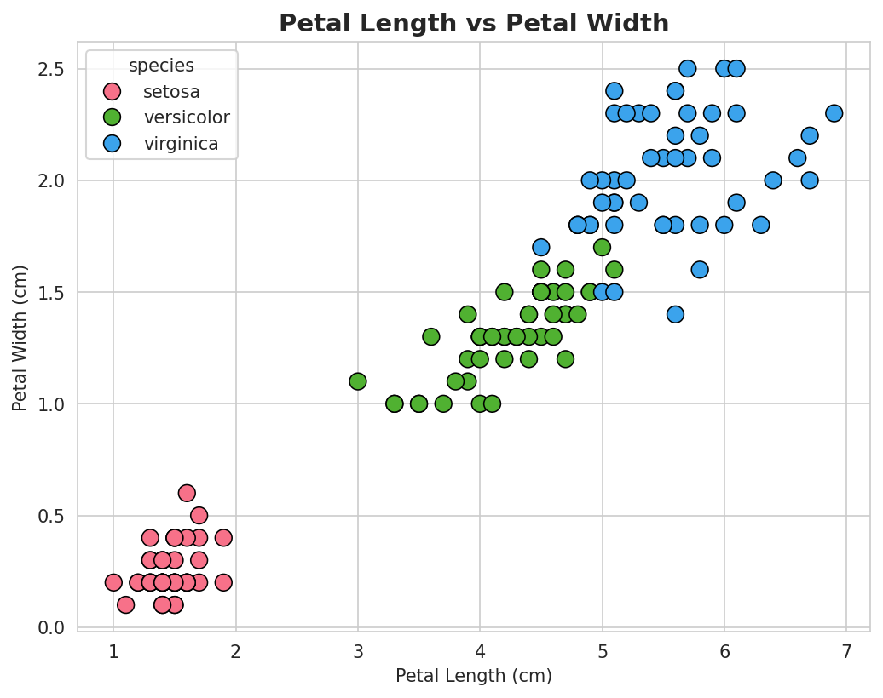
Figure 1: Scatter plot of Petal Length vs Petal Width, colored by species.
The scatter plot shows a clear positive linear relationship between petal length and petal width as petal length increases, petal width tends to increase too. The correlation coefficient between the two variables was found to be very high (≈0.96), confirming that a linear model is an appropriate choice for this data.

5. Model Training
The dataset was split into 80% training data (120 records) and 20% testing data (30 records) using a fixed random seed (random_state=42) for reproducibility. A LinearRegression model from scikit-learn was then trained on the training set. The fitted model equation is approximately:
Petal Width = -0.3567 + (0.4132 × Petal Length)
This means that, on average, each additional centimeter of petal length is associated with an increase of about 0.41 cm in predicted petal width.

6. Model Evaluation
The trained model was evaluated on the unseen test set using standard regression metrics:
Metric | Value
Intercept (b0) | -0.3567
Slope / Coefficient (b1) | 0.4132
Mean Absolute Error (MAE) | 0.1682 cm
Mean Squared Error (MSE) | 0.0456
Root Mean Squared Error (RMSE) | 0.2136 cm
R² Score | 0.928

An R² score of 0.928 means the model explains about 92.8% of the variance in petal width using petal length alone — indicating a very strong linear fit.

7. Visualizations

7.1 Regression Line Fit
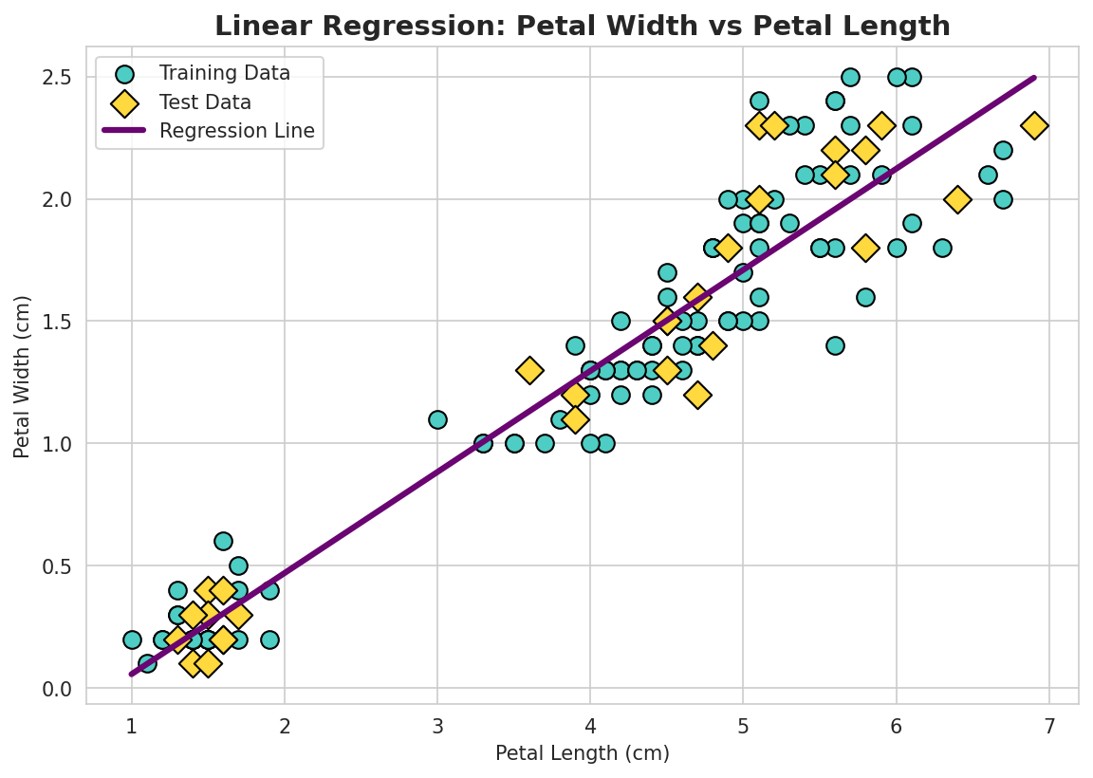
Figure 2: Fitted regression line against training and test data.

7.2 Actual vs Predicted Petal Width
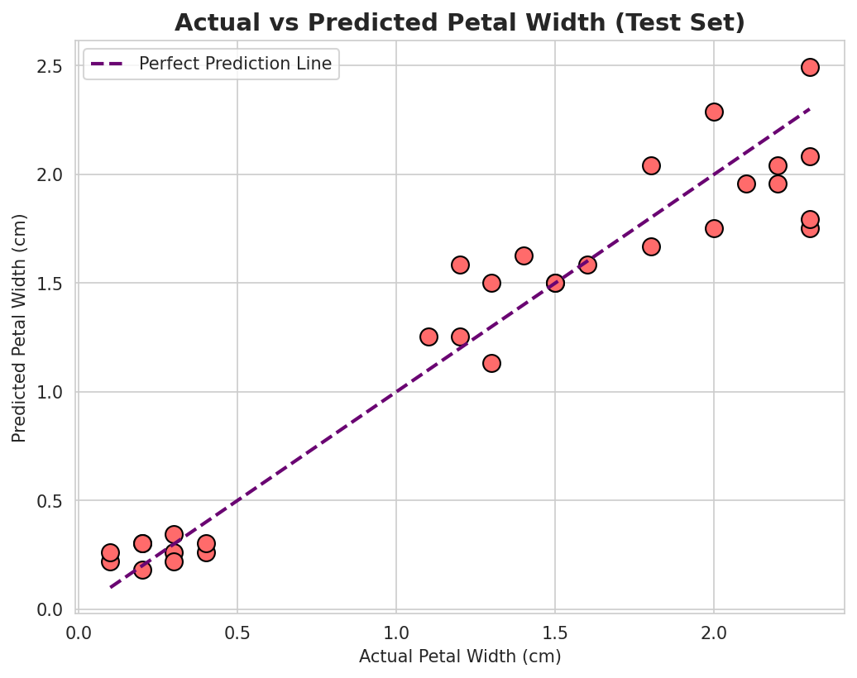
Figure 3: Actual vs predicted petal width for the test set. Points close to the diagonal line indicate accurate predictions.

7.3 Residual Plot
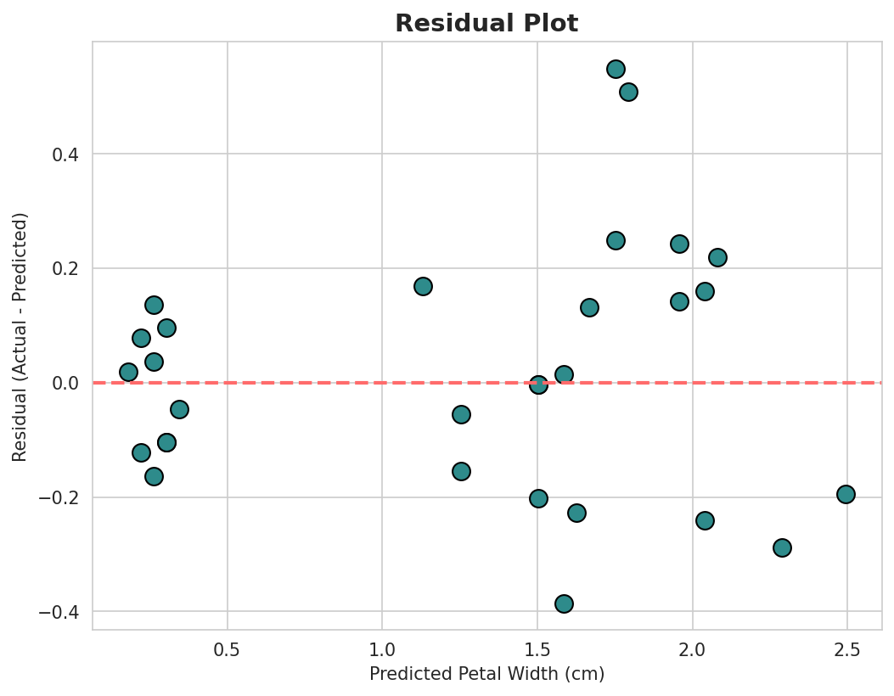
Figure 4: Residuals (errors) plotted against predicted values.
The residuals are scattered fairly randomly around zero with no strong pattern, which confirms that a linear model is well-suited to this data without major systematic bias.

8. Example Prediction
Using the trained model, the predicted petal width for a flower with a petal length of 4.5 cm is approximately 1.50 cm, calculated as -0.3567 + (0.4132 × 4.5).

9. Conclusion / Key Insights
- There is a strong positive linear relationship between petal length and petal width in the Iris dataset (correlation ≈ 0.96).
- The trained Linear Regression model achieved a high R² score (0.928), showing it explains most of the variance in petal width.
- The residual plot shows no strong pattern, confirming linear regression is an appropriate model choice.
- The model can be used to predict petal width for new flowers based on their petal length.
- Future improvements could include using additional features (sepal length/width) for a multiple linear regression model, or comparing performance across the three species separately.

10. Tools Used
- Python 3, Jupyter Notebook
- pandas, numpy for data handling
- matplotlib, seaborn for data visualization
- scikit-learn for model training and evaluation

